TROY USD 429
WEEKLY ACTIVITIES SCHEDULE – Week 6
OCTOBER 2-7– Bus Duty 2
Monday, October 2
TMS Tri @ Onaga w/NEK Topeka – 4 PM
Bus Departs @ 1:45 PM/ Driver - / 500 High St., Onaga, KS / 1 hr. 25 min.
Livestream Link: NFHS (Must have subscription)
https://www.nfhsnetwork.com/events/onaga-high-school-onaga-ks/gam6cd0d9b321
Juniors to HCC College Fair
Bus Departs @ 8:30 am/ Driver -
Tuesday, October 3
Body Venture – Gr. K-5 @ C.W. Oliver Gymnasium – PLEASE SEE SCHEDULE HARLEY EMAILED OUT
THS Volleyball Quad @ Onaga w/BV Randolph & Axtell – 5 PM JV/ 6 PM - Varsity
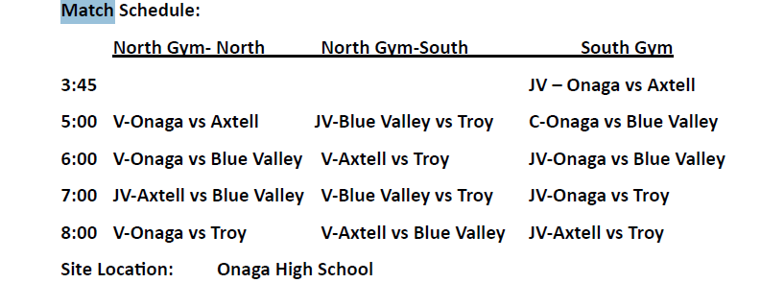
Bus Departs @ 2:40 PM/ Driver / 500 High St., Onaga, KS / 1 hr. 25 min.
NHFS Streaming Link: (Must have subscription)
https://www.nfhsnetwork.com/events/onaga-high-school-onaga-ks/gamd3c5adcd44
Wednesday, October 4
TMS Cross Country @ St. Joseph Christian – 4 PM
Race Times:
4pm - 8th Grade Girls and Boys
7th Grade Girls and Boys following 8th grade. ALL RACES WILL BE 2 MILES
Bus Departs @ 2:15 PM/ 5401 Gene Field Rd., St Joseph MO / 17 min.
Thursday, October 5
Grade 4/5 to St. Joseph Symphony
Bus Departs @ 12:30 PM/ 120 S Eighth St., St Joseph MO/20 min.
TMS VB / FB @ Troy vs DWEST – VB @ 5 PM (B team followed by A team)/ FB (8 man) @ 6:30 PM
Livestream Link: NFHS (must have subscription)
VB – https://www.nfhsnetwork.com/events/troy-high-school-troy-ks/gam2db3ef9aae
FB - https://www.nfhsnetwork.com/events/troy-high-school-troy-ks/gam2261ad53d0
Friday, October 6
NO SCHOOL
TEACHER INSERVICE
THS Football @ Jackson Heights – 7 PM
Bus Departs @4 PM / Driver – Bobby Watkins/12719 266th Rd., Holton, KS/56 min.
Cheer Departs @ 5:30 PM/ Driver - ? /
Saturday, October 7
THS VB @ Riverside (Elwood, KS) – 9 AM
2 Vehicles Depart @ 7:45 AM/ 204 N 12th St., Elwood, KS/19 min.
TMS OTL Volleyball @ Onaga – TBA
Bus Departs @ TBA/ 500 High St., Onaga, KS / 1 hr. 25 min.
Livestream Link: NFHS (must have subscription)
https://www.nfhsnetwork.com/events/onaga-high-school-onaga-ks/gamc3bcf01a2a

